School Of Computer Science

Halbert AI
(Chat Bot)

Himanshu Joshi
Roll no 2
11401392
K1424

HalbertAI
It is a type of conversational agent, a computer program designed to simulate an intelligent conversation with one or more humans via auditory or textual methods.
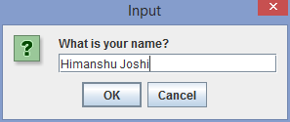

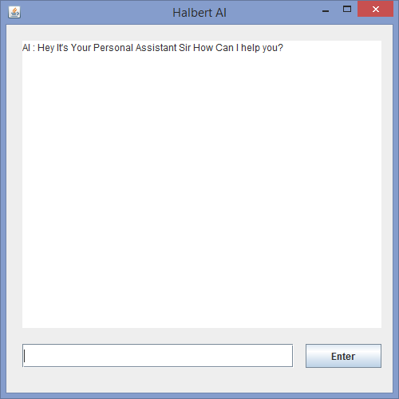

One thing it's fun, It can be used for information exchange with a customer in commercial websites/programs to teach children grammar, and other subjects through a interface using voice, animation, etc.

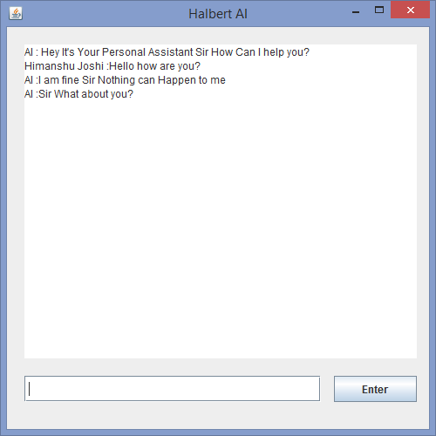
It is a project based on Java Language. The speech API used in this bot is Sphinx4.

